**EXPERIMENT 1**

Create a simple cloud software application and provide it as a service using any Cloud Service Provider to demonstrate Software as a Service (SaaS).

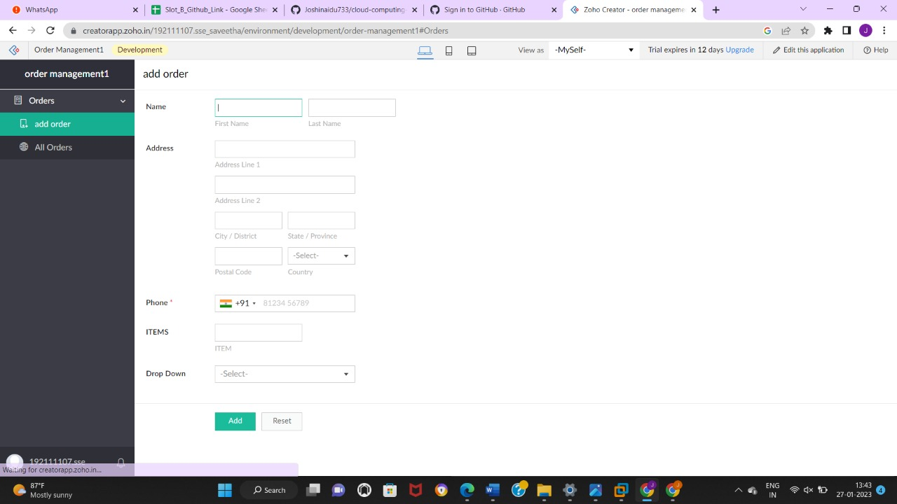

**EXPERIMENT 2**

Create a simple cloud software application for Flight Reservation System using any Cloud Service Provider to demonstrate SaaS

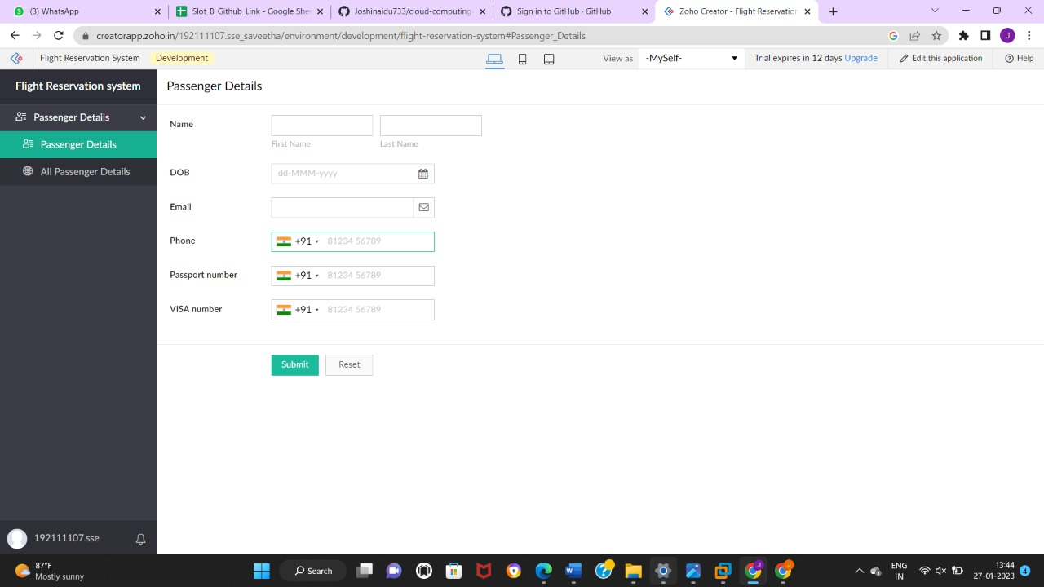

**EXPERIMENT 3**

Create a simple cloud software application for Property Buying & Rental process (In Chennai city) using any Cloud Service Provider to demonstrate SaaS

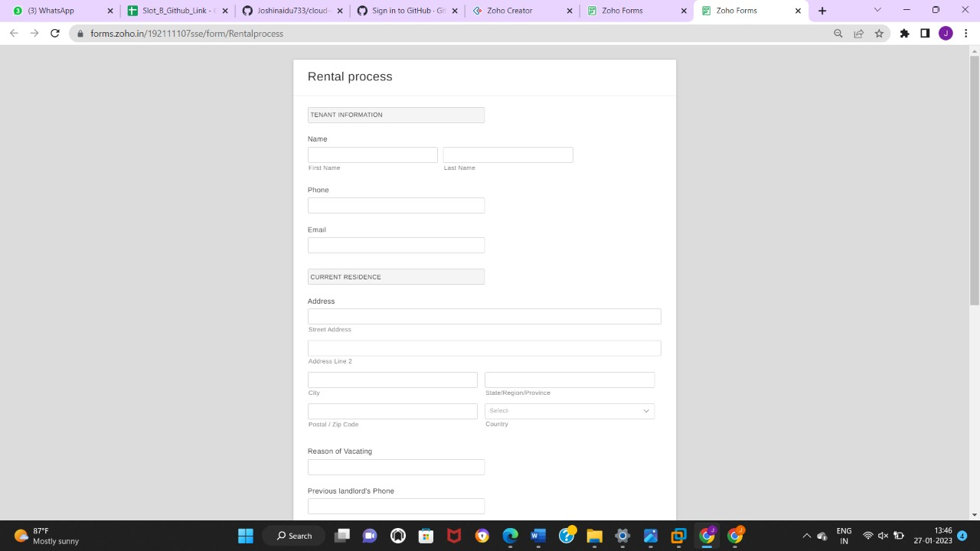

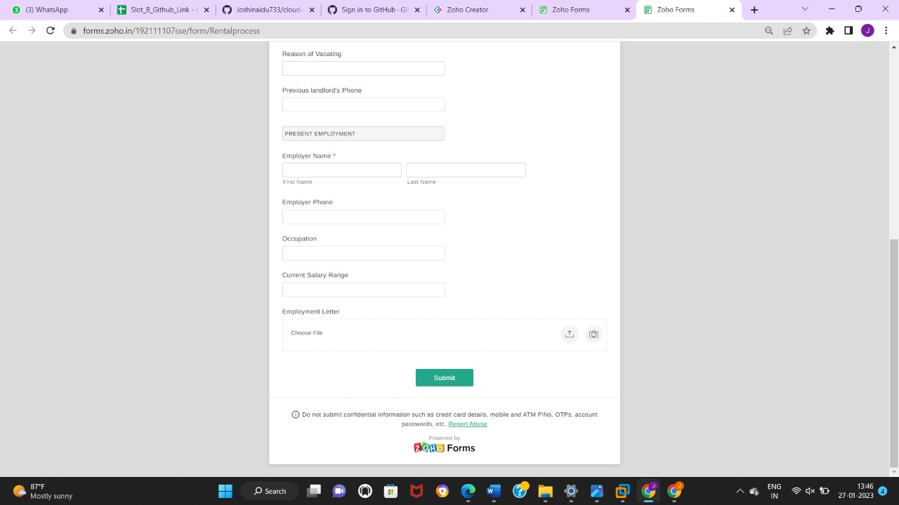

**EXPERIMENT 4**

Create a simple cloud software application for Car Booking Reservation System using any Cloud Service Provider to demonstrate SaaS.

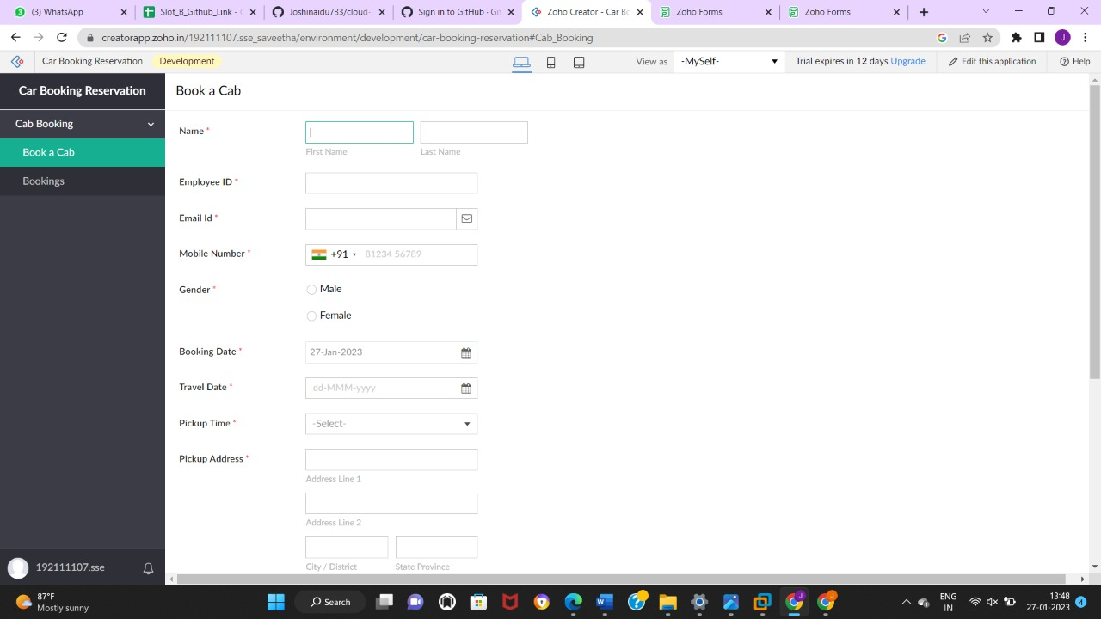

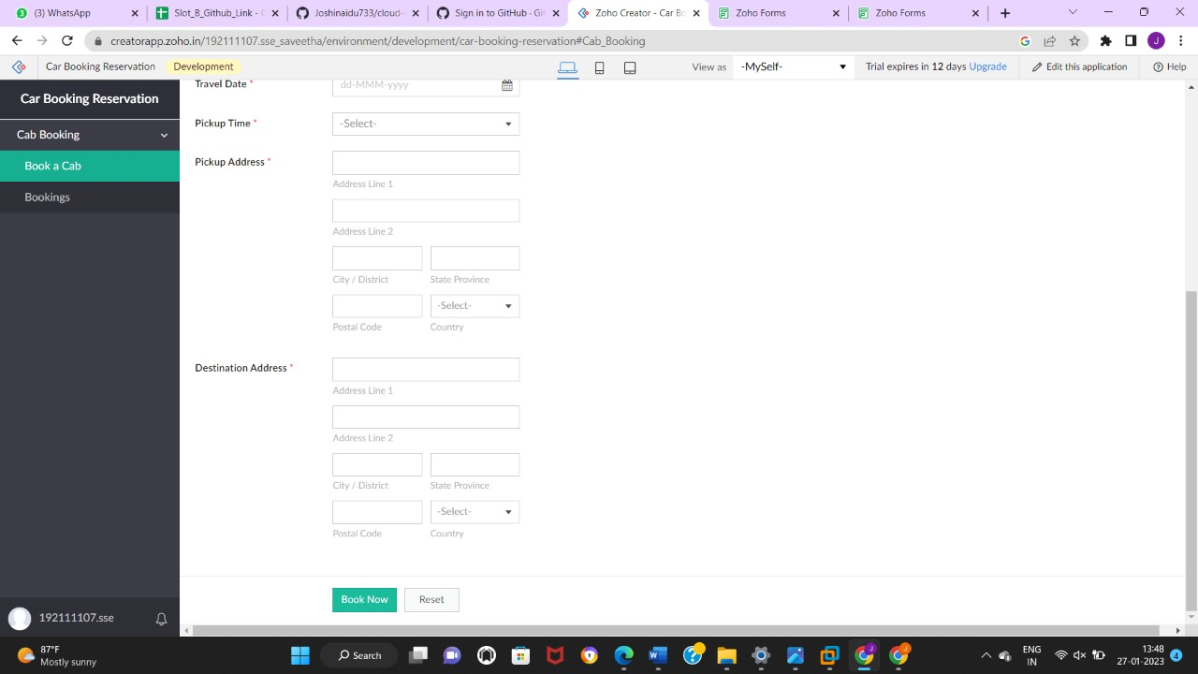

**EXPERIMENT 5**

Create a simple cloud software application for Library book reservation system for SIMATS library using any Cloud Service Provider to demonstrate SaaS

